Array Session

1st and foremost data structure is Arrays.

Q. What are the roadblocks to over come which arrays comes in picture ?
A. It’s is before array, if we need to work on multiple values, we can’t take multiple variables to store each and every value and perform operations, SO arrays helps us in storing multriple values under a single variable name.

Arrays : Collection of elements of similar datatypes.
Arr[] : {1,2,3,4,5}

Array stores only homogenroes data and not heterogeneous data

Each value in array is called and Element.

In the Arrays, the element positions is called as indexes. And the address of elements in array i.e indexs will be of natural numbers, i.e they starts with 0.

And the 1st elements index will be 0 and the last elements index will be n-1. Where n is the size of the array.

Q. What time it’ll take to access the elemensts in the array ?
A. constant time i.e O(1) => Best case scenario {for accessing the 0th index element }
O(n) => Worst case scenario.{ for accessing the nth index element }

Q. Time taken for the following code snippet ?
for(i=0; i<n;i++){
print(A[i]);
}

A. O(n)

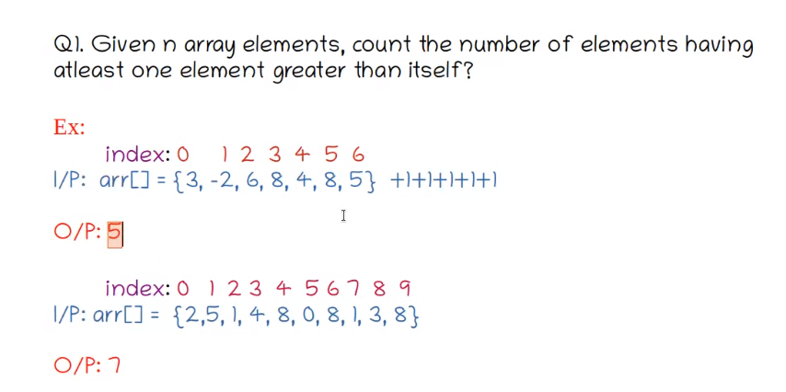
Q. Which element will never have a greater value in array {3,-2,6,8,4,8,5}
A. 8

Q. Given n array elements, count the number of elements having atleast one element greater than itself? {arr = {3,-2,6,8,4,8,5}}
A. Simple procedure is Find the max element in the array and count the occurennces of max.
Then simple subtract the count max from size of array. i.e for above problem, max is 8 and count of max is 2 and size of array is 7, so simple 7-2 =5 is the answer.

Ans : 5

//Code for that,

int [] arr = {3,-2,6,8,4,8,5};
int max = Integer.MIN_VALUE;
int count =0;
for(int i=0; i<arr.length; i++){
if(arr[i]>max){
max = arr[i];
}
}
for(int i=0; i<arr.length; i++){
if(arr[i]==max){
count++;
}
}

System.out.println(arr.length - count);

The Time Complexity will be : For 1st for loop O(n) and for second for loop O(n)
i.e O(n) + O(n) -----> Nearly We can say O(n)

But if we use Arrays.sort(arr) : Java internally uses meger sort.
TC of it will be : O(n Log n) ---> Which is worst than O(n)

// The main purpose of DSA is finding the best optinal way to reduce time and space complexity and proceed with our operations.

And also the space complexity for the for loop one is O(1)

Next Question :
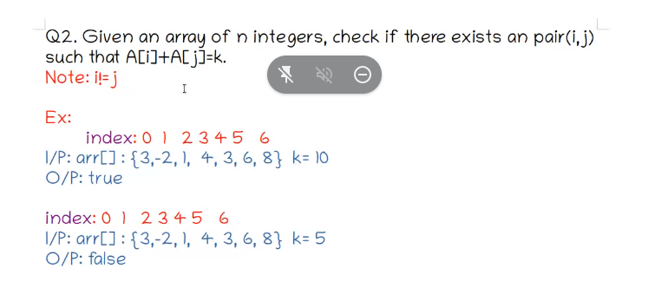

One Brute force approch is :

int [] arr = {3,-2,1,4,3,6,8};
int k =10;
boolean flag = false;
for(int i=0; i< arr.length; i++){
for(int j=0; j<arr.length; j++){
if(i!=j && arr[i]+arr[j]==k){
flag = true;
}
}
}
System.out.println(flag);

But time complexity is more here and not an optimal way.

--> Some another better approch is ,

right now we’re checking i!=j and for every value of i we’re checking again as well.

If i=0, we need to check for j = 1,2,3,4 considering 4 is the arr.length -1
similarly if i=1, we check for j = 2,3,4 and i = 2 , we check for 3,4 and so on.

Just like image below.

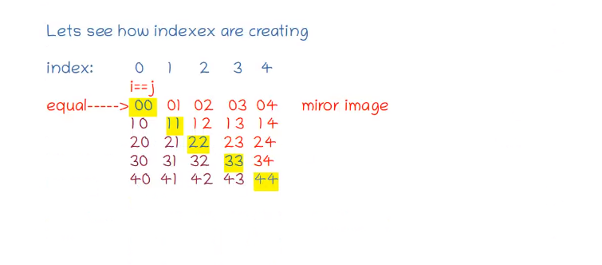

So, This means we need to start i =0, and j = i+1

int [] arr = {3,-2,1,4,3,6,8};
int k =10;
boolean flag = false;
for(int i=0; i< arr.length - 1; i++){
for(int j=i+1; j<arr.length; j++){
if(arr[i]+arr[j]==k){
flag = true;
}
}
}
System.out.println(flag);

// This way is reducing the iterations to almost half, so that the time complexity also getting reduced here. This is a beter optimal way.

Coming to time complexity :

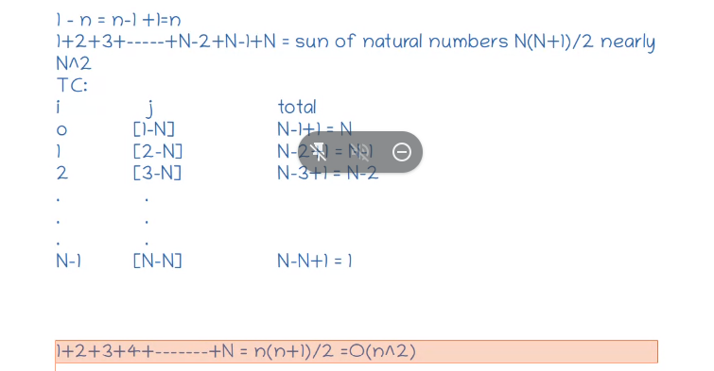

Next Question :

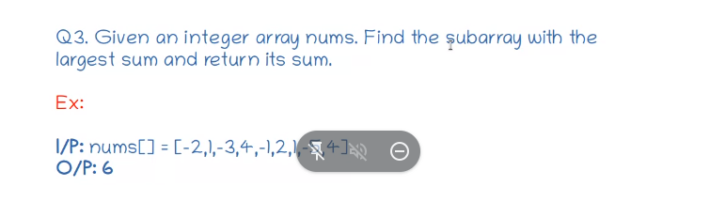

Sub Array : A continous part of an Array
Consider the array[1,2,3,4,5]

- For this, [2,3], [1,2,3], [4,5] etc are sub arrays cuz they’re contionus parts of the array

- But, [1,5], [2,5], [1,3] etc are not sub arrays , cuz they’re not continous parts of the array.

Formula for nuber of sub arrays for a particular array is n(n+1)/2 where n = Array size
Take an array [1,2,3] then No.of Sub Arrays are : 3 (3+1)/2 = 6
[1] [2] [3] [1,2] [2,3] [1,2,3] are the sub arrays of the above array and they’re 6.

For Finding these sub arrays , we need start index and end index like below

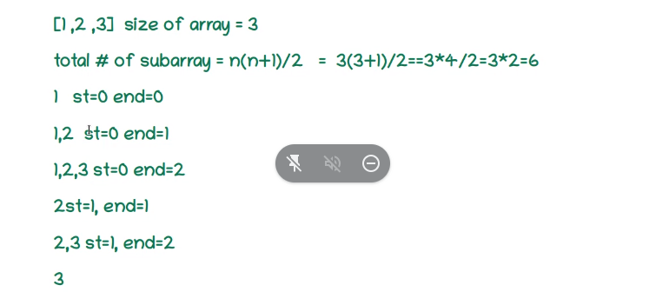

So, while solving the above problem,

Using Brute Force.

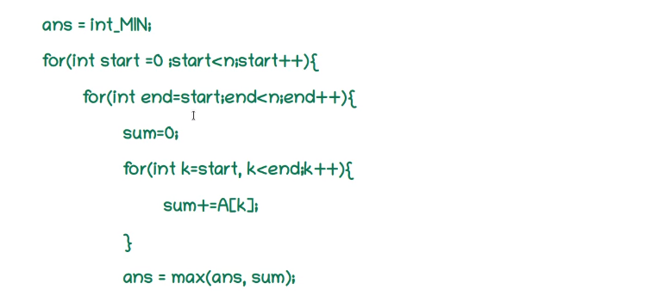

But time complexity is huge here,

So, Here the Optimal Solution is ,

